CO. standard 1. Movement Competence & Understanding in Physical Education
Evidence outcome 2.e: Balance demonstrating momentary stillness in symmetrical and nonsymmetrical shapes on a variety of body parts (DOK 1-3)
4= Advanced 3= Proficient 2= Partially proficient 1= In progress
Students consistently demonstrates extraordinary abilities in: leading/mentoring/inspiring others in, creative application of, or specific aptitude in the skills, concepts, or principles of this skill. | Student consistently demonstrates responsibility for self and others when performing a handstand at the wall using the cues of: hands flat, arms straight, strong core, and lands on the feet. | Student performs a handstand at the wall using almost all the cues of: hands flat, arms straight, strong core, and lands on the feet. | Student performs a handstand at the wall using only one or two of the cues: hands flat, arms straight, strong core, and lands on the feet.

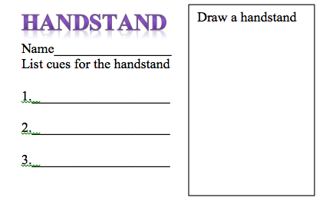
A cognitive pre- & post-assessment was employed to measure students’ understanding of the handstand and it’s movement cues before and after the unit of instruction.. Measure of grade 3
NASPE standard 2. The physically literate individual applies knowledge of concepts, principles, strategies and tactics related to movement and performance.
Evidence outcome 4.3a Employs the concept of alignment in gymnastics and dance.
Evidence outcome 4.3b Employs the concept of muscular tension with balance in gymnastics and dance.
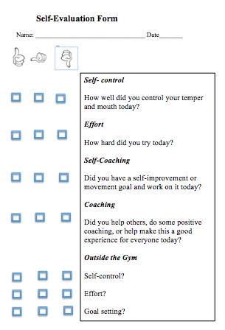
This affective self-assessment was designed to help students consider their responsibility levels while participating in this physical education unit.
CO. standard 3. Emotional and social wellness
Evidence outcome 1.a: Identify the positive behaviors of self and others (DOK 1-2)

Self-assessment rubric of criteria
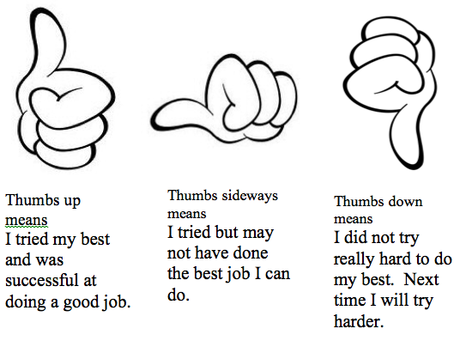

Name_________________________________________ Grade____ Yellow Green

Checklist of cues for the overhand serve

Name_________________________________________ Grade____ Yellow Green

✔ | Movement cue | Comments
 | Contact is made in correct rhythm with transfer of weight from back to front foot.
 | Contact is made low and close to the core.
 | Contact is made with the palm pad of the hand for aim.
 | Contact is made with the ball still sitting in other hand.
Checklist of cues for the underhand serve
✔ | Movement cue | Comments
 | Ball is thrown up 2-3 ft & slightly in front of hitting shoulder.
 | Contact is made in correct rhythm with transfer of weight from back to front foot.
 | Contact is made with hitting arm fully extended.
 | Contact is made with the palm pad of the hand for aim.

