Invasion game – Team handball
Grade 6 30 min 22 students Lesson 3 gymnasium

Standards addressed:
Throws, while stationary, a leading pass to a moving receiver. (S1.M5.6)
Creates open space by using the width and length of the field/court on offense. (S2.M3.6)
Reduces open space on defense by making the body larger and reducing passing angles. (S2.M4.6)
Cooperates with a small group of classmates during adventure activities, game play or team-building activities. (S4.M5.6)
Equipment: 22 gator skin balls, or a mix of round balls
Teacher objectives: Manage time appropriately by giving clear and concise instruction and watching the clock. Provide specific congruent corrective feedback to 5 students.
Student objectives: Use proper technique for throwing and catching in practice tasks. Discuss the difference between health related fitness components. Practice proper etiquette in physical education settings.
Task 1 (8 min): Throwing and target warm up
Each student gets a ball and a target on the wall. Hit the target as many times as you can in 60 seconds. Movement cues: Twist to coil up energy, point to target at release

Task 2 (8 min): Throwing to a moving target
4-5 groups of 5 each group has 3 balls and lines up at the end line.
First person in line runs across the court, second person throws to the first person then begins to run. Second person then turns to receive a thrown pass by the third person in line. When a student catches a pass they run to the end of the line and hands the ball up to the next person in line. Movement cues: throw in front of the runner, runner try to catch while moving.

Task 3 (8 min): Small sided game play
3 v 3 or 4 v 4. Learning targets: Offense spread out – use width and length of field. Defense make body larger to block and reduce passing angles.
Invasion game – Team handball

Content Area/Skill theme __DANCE__Class skill level_K-3_ control_

Length of lesson _45 min. Class size ___22__ Lesson # _2__ School Olander Elem.__

Equipment: Poly spots, ribbons, cones, one die with pathways on it, pencils and paper assessments, (8) gator balls.
Facility: Gymnasium
Script notes:
A different colored cone should be the third from each end line to provide a visual cue for students to go. This keeps students separated enough but not waiting.
Place receptacles for pencils and paper assessments in the middle of the “shark circle”.

NASPE Standards:
- (S2.E3.3) Combines movement concepts (direction, levels, force, time) with skills as directed by the teacher.
- (S5.E2.3) Discusses the challenge that comes from learning a new physical activity.
Colorado State/District Standards:
- (S1.1.a.) Demonstrate changes of pathways, levels, forces, and direction with manipulatives such as hoops, streamers, and balls (DOK 1-3)
- (S2.2.c.) Locate the heart, and feel it beat after moderate to vigorous exercise (DOK 1)
Teacher Objectives: Arrange organization of students during demonstrations appropriately according to their developmental level. Refer to 10 more students by name. Hand out 5 Flying Highs for good behavior.
Student Objectives: SWBAT
- Psychomotor: Demonstrate sharp and smooth movements with a variety of body parts.
- Cognitive: Recognize the difference between sharp and smooth movements.
- Affective: Describe the difference between the way they feel when performing sharp versus smooth movements.

Approx. time | Student activities (anticipated progression of tasks) | Performance cues | Goal orientation (inform, extend, refine, apply, assess, etc) | Organizational arrangement (include grouping & task present method)
1 min | Tap in and Run two laps | Outside of the red rectangle | Warm up
5 min | Draw pathways | You may not know what they are, but draw what you think they are in these boxes.  Do it by yourself. | Pre-assessment  cognitive | Students sitting at edges of the room.
2 min | To the tune of “head shoulders knees and toes”, but I changed the words. Shoulders, hips knees and ankles. Elbows, Wrists and core and nose | What do shoulders hips knees and ankles have in common? They are your Joints.  Strongest part of body is core.  Nose points to facing. | Inform | Students with two feet on “shark circle”.
2 min | ¼ turn to change facing and Repeat song. Do 2x to end up facing outside the circle then ½ turn stop | Facing a person next to you do it in fast motion!, facing outside the circle do it in part slow motion part fast motion, face back inside the circle! | Extension | Students on the “shark” circle.
10 min | Tag game: Leading movement with body  parts: shape Round 1= square  Round 2= circle  Round 3= triangle | Get tagged with the ball draw a shape in space leading with a new body part each time you are tagged. | Extension | Students with two feet on “shark circle” while I explain the game.
2 min | Inquiry | Circle is smooth.  Square is sharp.  How does moving like this make you feel? | Discussion | Students with two feet on “shark circle”.
3 min | Changing direction and levels with Ribbons | Move ribbon in a straight pathway up and down, to the right and left, jump.  Curvy pathway up to down and left to right, then zig zag.  Circle around (spin) | Extension | Students with two feet on “shark circle”.
5 min | Moving the whole body along different pathways: run.  Students in line count music, 5678 and then begin moving on 1. | Weave through the cones with rounded turns = curvy path.  Weave through cones with sharp turns = zig zag pathway. | Extension | Students begin on end line of basket ball court and travel to the other end line and back.
3 min | Rock and roll the dice | Die says Which pathway to do.  1st person rolls the die and all travel that pathway to the other side of court. | Application | Students begin on end line of basket ball court and travel to the other end line and back.
3 min | Inquiry | How did moving smoothly on the curvy pathway feel?  How did moving sharply on the zig zag pathway feel?  How did running in a straight line make you feel? | Closing | Students with two feet on “shark circle”.

Dice words
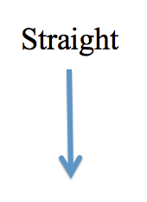
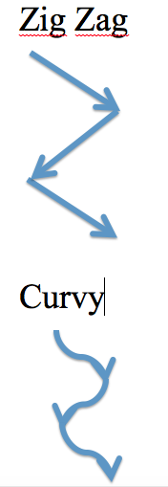
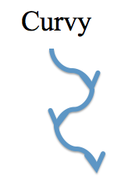

Content Area/Skill theme _Acrobatics___Class skill level__3rd grade _control_

Length of lesson _45 min. Class size __24____ Lesson # _1__ School Olander Elem.__

Equipment: 6 panel mats, 6 cones, task cards, open wall space clear of posters, etc.
Facility: gymnasium (hallway)

NASPE Standards:
- (S1.E1.4) Uses various locomotor skills in a variety of small-sided practice tasks, dance and educational gymnastics experiences.
- (S2.E1.3)Recognizes the concept of open spaces in a movement context.
- (S4.E1.3) Exhibits personal responsibility in teacher-directed activities.
- (S5.E2.3)Discusses the challenge that comes from learning a new physical activity.
Colorado/District Standards:
- (S1.2.e) Balance demonstrating momentary stillness in symmetrical and nonsymmetrical shapes on a variety of body parts (DOK 1-3)
- (S2.2.c) Locate the heart, and feel it beat after moderate to vigorous exercise (DOK 1)
- (S2.2.b) Identify muscles and fat (DOK 1)
- (S3.1.b) Congratulate partners, opponents, or team upon conclusion of game or activity (DOK 1-2)
Teacher Objectives: Stress SAFETY in this risky unit of instruction through repetition and holding students accountable. Clearly and thoroughly address all management cues and protocols. Organize in a way that transitions between tasks are clear and efficient.

Student Objectives: SWBAT
- Psychomotor: Perform a handstand at the wall using the cues of hands flat, straight arms, and landing on the feet.
- Cognitive: Describe the reason for not holding the flyer’s ankles when performing a partner handstand.
Discuss the challenge that comes with learning a new activity.
- Affective: Congratulate partner after performing an acrobatic skill.

Approx. time | Student activities (anticipated progression of tasks) | Performance cues | Goal orientation (inform, extend, refine, apply, assess, etc) | Organizational arrangement (include grouping & task present method)
2 min | Tap in and run two laps | Tell us how you feel your level of responsibility will be in class today | Warm up | Around parameter of gym
4 min | Safety | Acrobatics is risky. Is risk-taking fun or scary?  Do not run into anyone else – so group space  Do not let any ones’ head hit the ground – so let go of feet first! | Introduction | Students sitting in straddle position on “shark” circle
2 min | Handstands at the wall | Don’t bump into anyone else  Look at your toes  Land on your feet | Extension | Students at parameter of gym
30 sec | Handstands at the wall | Hands flat  Arms straight  Strong core  Feet in front of your eyeballs | Refinement | Students at parameter of gym
10 sec | Handstands at the wall | Hold for ten seconds  Land on your feet | Application | Students at parameter of gym
2 min | What is acrobatics? | Discuss challenge that comes from learning a new physical activity  Balance with a Partner | Inform | Students on “shark circle”, first discuss with the person next to you, then with class
2 min | Handstands with a partner | Base: feet on shoulders  Hands off feet.  Flyer: Same as handstand at the wall | Extension | Students in self space scattered around gym
30 sec | Inquiry/safety | Why do you think the base should keep hands off the feet?  So the flyer lands on their feet not their head | Assess verbally | Students in self space scattered around gym
15 min | Stations of simple acrobatic skills. Teacher takes a picture of one group at every station | Do not let your partner’s head hit the ground  Keep a strong core.  Hands flat on the ground. | Extension | Students in groups of 4 rotate on signal to new station around parameter of gym.
2 min | All together now perform acrobatic skills on teacher’s command | Hold Bunk Beds for 10 seconds | Application /Pre-Assessment | Students scattered throughout general space
12 min | Acrobatics/ locomotor game Do locomotor dance skill around the room until given a signal to find a partner or group for actobatic skill | Find open spaces to perform acro.  Don’t bump into others  Strong cores!  Don’t let anyone’s head hit the floor  If you do not find a partner or group in the designated time, go to wall to do handstand for 10 seconds and then you’re back in the game. | Extension | Students scattered throughout general space
3 min | Discuss challenges of learning a new physical activity. | Practice makes improvement  Work out muscle groups needed to perform acrobatic skills | Discussion /closing | Students around “shark” circle
2 min | Ready for exit | Line up quietly so we can get a bead on the bead chart | Affective assessment | Students on red line

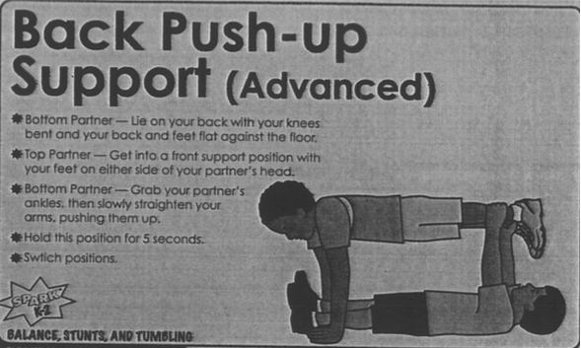
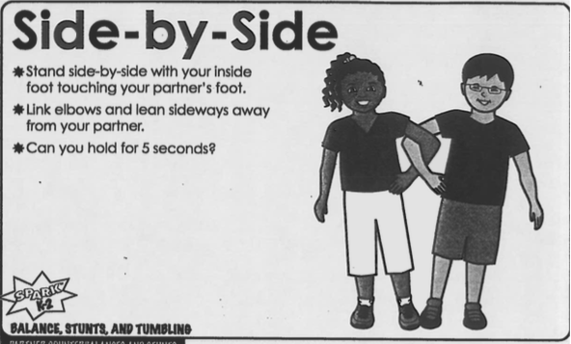
Station task cards
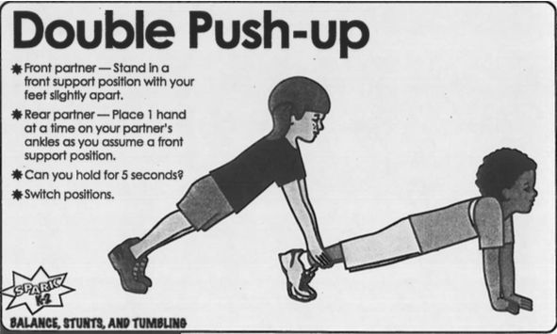
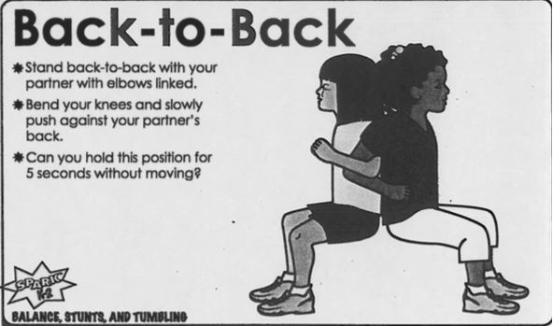
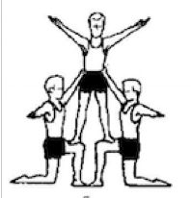
Lunge pyramid done with teacher.

6th station is building a house of cards.

Content/ skill theme Volleyball lesson 3 Grade 6. Length 30 min.

Standards addressed:
Strikes, with a mature overarm pattern, in a non-dynamic environment for net/wall games such as volleyball, handball, badminton or tennis. (S1.M13.6)
Reduces offensive options for opponents by returning to mid-court position. (S2.M8.6)
Identifies major muscles used in selected physical activities.16 (S3.M14.6)
Demonstrates respect for self and others in activities and games by following the rules, encouraging others and playing within the spirit of the game or activity. (S5.M6.6)
Equipment: 25 volleyballs, 1 net Location: gymnasium

Teacher objectives: Be patient and kind- do not react to students’ poor attitudes with a poor attitude. Make clear the rule regarding saying the word “can’t”. Clearly communicate expectations and objectives for the day.

Student objectives:
Psychomotor: Move feet to return to starting position after forearm passing the ball to a partner.
Cognitive: Recognize movement cues during video analysis of personal practice of the volleyball serve.
Affective: Respect self and others by following the rule regarding the phrase “I can’t” and giving high fives to classmates following game play.

Approx. time | Student activities (anticipated progression of tasks) | Performance cues | Goal orientation (inform, extend, refine, apply, assess, etc) | Organizational arrangement (include grouping & task present method)
4 min | Instruction | Remember rules etiquette.  Rotate stations on my signal. | Inform | Seated in front of white board
4 min | Station 1: video analysis | Use the correct sheet for writing your feedback.  Watch and help others in your group do the analysis.  1 minute per person | Self assessment | Students sitting on bleachers
4 min | Practice of the volleyball serve | Demonstrate self-responsibility by implementing specific corrective feedback to improve performance. | Refinement (from previous lesson) | Students on the volleyball court hitting over the net
4 min | Bumping to self | - One hand wraps the other  - soften hips and knees  - hit with straight arms  - little bumps for control | Refinement (from previous lesson) | Students on one side of 2nd volleyball net
 | How many times can you bump to yourself without losing control? | - After 50 times come and find teacher for an added challenge | Application | Students on one side of 2nd volleyball net
4 min | Throw, bump, catch with a partner: make your partner move their feet to get behind the ball | - Hit your target  - Move feet to return to starting position after forearm passing the ball to a partner. | Refinement (from previous lesson) | Students on one side of 2nd volleyball net
 | How many times can your use the forearm pass to hit you target? | - After 4 out of 5 times successfully hitting to your target move to next task. | Application | Students on one side of 2nd volleyball net
 | Challenge by choice | IF successful at hitting target during previous task: Forearm pass back and forth with a partner | Extension | Students on one side of 2nd volleyball net
4 min | Queens of the court  Small sided game play | - 2-3 hits on your side.  - Legal hit over the net. | Extension /apply previously practiced skills in a dynamic environment | Students in self space scattered around gym
30 sec | Ready for exit | Give 2 people who were not on your team a high five. | Affective

